Style Guidelines for Final Year Project ReportsRogue AI

Final Year Project – Final Report

Session 2017-2021

A 4th Year Student

A project submitted in partial fulfilment of the

COMSATS University Islamabad, Lahore Campus

Degree

of

BSc. (Hons.)BS in Software Engineering (CUI)



Department of Computer Science

COMSATS University Islamabad, Lahore Campus

30 June 2021

# Project Detail

|  |  |  |  |  |
| --- | --- | --- | --- | --- |
| **Project Group Members** (To be filled by students) | | | | (To be filled by supervisor) |
| Sr.# | Reg. # | Student Name | *Signature | Obtained Marks  (Total Marks: 10) |
| (i) | FA17-BSE-011 | Muhammad Humza Butt |  |  |
| (ii) | FA17-BSE-071 | Maha Muzammil Ejaz |  |  |
| (iii) | FA17-BSE-038 | Sheikh Umer Saeed |  |  |

*The candidates confirm that the work submitted is their own and appropriate credit has been given where reference has been made to work of others.

**Plagiarism Free Certificate**

This is to certify that, I am **Muhammad Humza Butt** S/D/o group leader of FYP under registration no **CIIT/FA17-BSE-011/LHR** at Computer Science Department, COMSATS Institute of Information Technology, Lahore. I declare that my FYP proposal is checked by my supervisor and the similarity index is 5 % that is less than 20%, an acceptable limit by HEC. Report is attached herewith as Appendix A.

Date: **14/6/2021** Name of Group Leader: **Muhammad Humza Butt**

Supervisor Name: **Asmara Safdar** Supervisor Signature: ______________

Co-Supervisor Name: **Mohsin Mehdi** Supervisor Signature: ______________

Remarks (if any): ______________________________________________________________

**Abstract**

Rogue AI will be a mix between FPS and a logical riddle-solving game in which players are required to solve the different logic puzzles to move forward and defeat robotic enemies. It is designed to test player’s intelligence and logic-building skills by solving puzzles all while fighting robotic enemies in a challenging environment.

Acknowledgment:

By the grace of Allah, I was able to start, work on and complete this project on time.

I would like to thank my friends and family for their support and their incredible ideas for making this game more fun.

I would also like to thank my supervisors, Asmara Safdar and Mohsin Mehdi for their help, guidance, and motivation, without which this project would never be completed.

Thanks to Abdullah Khalid and Osama Akhtar who supported me throughout the development cycle in every way.

Table of Contents

1. Introduction 12

1.1 Introduction 12

1.2 Objectives 12

1.2.1 Main Goals 12

1.2.2 Objectives 12

1.3 Problem Statement 13

1.4 Assumptions and Constraints 13

1.4.1 Assumptions 13

1.4.1.1 Product Delivery 13

1.4.2 Constraints 13

1.4.2.1 Performance 13

1.5 Motivation and Scope 13

1.6 Game Scope 13

2. Requirement Analysis 16

2.1 Literature Review 16

2.1.1 Portal 16

2.1.2 Quantum Conundrum 17

2.1.3 Portal 2 17

2.1.4 Half-Life 2 18

2.2 Stakeholders (Actors) 19

2.3 Requirement Elicitation 19

2.3.1 Functional Requirements 19

2.3.2 Non-Functional Requirements 23

2.4 Use Case Description 24

2.4.1 Launch Game 24

2.4.2 Design 25

2.4.3 Play Match 26

2.4.4 Design 27

2.5 Game / Software Development Life Cycle (SDLC) 28

3. System Design 30

3.1 Work Break down Structure 30

3.2 Activity Diagram 31

3.2.1 Launch Game Activity Diagram 31

3.2.2 In Game Activity Diagram 32

3.2.3 Game Update Activity Diagram 33

3.3 Class diagram 34

3.4 Sequence Diagram 34

3.4.1 Sequence Diagram – Main Menu & In Game Activity 34

3.4.2 Sequence Diagram – Update Game 35

3.5 Game Flow Chart 36

3.6 System Architecture 37

3.7 Collaboration Diagram 38

3.8 Game Design and Implementation 39

3.8.1 Enemies 39

3.8.2 Animals 41

3.8.3 Player 43

3.8.4 User Interface 43

3.8.4.1 Login 43

3.8.4.2 Sign up 44

3.8.4.3 Map 44

3.8.4.4 Level screen 47

3.9 Riddles/Logical Puzzles 48

1. Unity Engine Testing 62

4.1 Test Case 62

4.1.1 Test Case Game Installation 62

4.1.2 Test Case Game Launching 62

4.1.3 Test Case Sounds 63

4.1.4 Test Case User Interface 63

4.1.5 Test case Performance 63

4.1.6 Test Case Puzzle Solving 64

4.1.7 Test Case Settings 65

4.1.8 Test Case Competition with the boss 65

4.2 Unity Engine Testing: 65

4.2.1 Game Installer Files 65

4.2.2 Models and their Animation 65

4.2.3 Player Game Object 66

4.2.4 Game Menu and Interfaces 66

5. Conclusion 68

5.1 Problem Faced and Lessons Learned 68

5.2 Project Summary 68

5.3 Future Work 68

5.4 GitHub Repository Links 68

6. References 70

6.1 Portal Game Play 70

6.2 Portal Wikipedia 70

6.3 Portal 2 Wikipedia 70

6.4 Half-life 2 Wikipedia 70

6.5 Quantum Conundrum Wikipedia 70

6.6 PUBG Mobile Wikipedia 70

6.7 COD Mobile Wikipedia 70

LIST OF TABLES

Table 1 20

Table 2 20

Table 3 20

Table 4 20

Table 5 21

Table 6 21

Table 7 21

Table 8 22

Table 9 22

Table 10 22

Table 11 23

Table 12 23

Table 13 23

Table 14 23

Table 15 23

Table 16 24

Table 17 24

Table 18 24

Table 19 25

Table 20 26

Table 21 62

Table 22 62

Table 23 63

Table 24 63

Table 25 64

Table 26 64

Table 27 65

Table 28 65

**LIST OF FIGURES**

Figure 1 16

Figure 2 17

Figure 3 18

Figure 4 19

Figure 5 25

Figure 6 27

Figure 7 30

Figure 8 31

Figure 9 32

Figure 10 33

Figure 11 34

Figure 12 35

Figure 13 36

Figure 14 37

Figure 15 38

Figure 16 39

Figure 17 40

Figure 18 40

Figure 19 41

Figure 20 41

Figure 21 42

Figure 22 42

Figure 23 43

Figure 24 43

Figure 25 44

Figure 26 44

Figure 27 45

Figure 28 45

Figure 29 46

Figure 30 46

Figure 31 46

Figure 32 47

Figure 33 47

Figure 34 47

Figure 35 48

**CHAPTER # 1**

**INTRODUCTION**

# Introduction

## Introduction

Rogue AI aims to be the warfare of humans vs robots with the chain of puzzles to be solved to achieve the goal and a sci-fi storyline. The game will help the player to make warfare strategies by intelligent decisions against the enemy and solving logical puzzles.

It will be a level-based game where the difficulty increases after each level. At the end level, the player has to compete with a robotic army and boss to recover the chip that can cause the end of the human race.

Such games are played by the vast majority of people in recent years regardless of age, gender, or profession. Intense games like ***Quantum Conundrum, Half-life 2,*** and ***Portal*** are huge successes.

**Character Types:**

|  |  |
| --- | --- |
| 1. **Player** | The player has to solve puzzles set by robots and fight with them to recover the microchip. |
| 1. **Enemy** | Enemies are AI robots who can follow and attack. |
| 1. **Alien Animals** | These are alien life forms that can be dangerous or healthy. Killing the right one can provide the player with health ups and vice versa. |
| 1. **Boss** | It will be found on the last level. The player has to fight and kill the boss to get the chip. |

## Objectives

### Main Goals

* To improve the logical skills of the player
* A deployable product to be launched in the market
* Develop a game with high player involvement
* To defeat the enemies and to recover the chip
* To make the logical skills of the person a part of his survival instincts by making he/her undergo various challenges.

### Objectives

* Develop a Desktop Game for entertainment
* Implementation through different tools and techniques of design, model, and development

## Problem Statement

In today’s world, games have become the mode of only having fun, due to which a person wastes lots of time playing such games. People tend to play games when they feel like they mentally have to relax which becomes an addiction in the future.

Moreover, in today’s world, people tend to shift more towards casual and battle games, which isn’t of any help to the user. Our game is designed in such a way that would be beneficial to the player. Our game is a mix of fun and learning. The game is specifically designed in a way that a user will be able to build his logical sense by solving logical puzzles along with having fun.

## Assumptions and Constraints

### Assumptions

#### Product Delivery

The product shall meet all deadlines and shall deliver what is intended to.

### Constraints

#### Performance

As desktop has boundless performance in terms of processing and graphics memory, Rogue AI! Will be kept performance insensitive and will be able to run on the majority sort of desktop devices.

## Motivation and Scope

The core motivation for this game is to persuade the user to think logically in adrenaline conditions. It will put the user in a situation to make faster and logical decisions for his survival. In a nutshell, this game will serve the purpose of providing fun along with polishing the spatial skills of the user.

We are developing this game as our Final Year Project along with considering the industry demand to hit the game market. The specifications are mentioned in the goals and objectives section.

## Game Scope

According to J. Schell, in his work “The Art of Game Design: A Book of Lenses” the scope of a game is defined by splitting into four categories: Mechanics, Story Line, Aesthetics, and Technology.

Rogue AI consists of a moderate level of Mechanical needs as it is a puzzle-solving game along with being an FPS game. The right answer to the logical puzzles shall decide whether or not the player shall be promoted to the next phase or not. The Mechanical aspect is only required for all levels i.e. when the player has to fight and kill the robots.

In terms of storyline, such games need a very minimal storyline which is enough to support the character’s look and personality. Rogue AI has a mixed timeline as it has a Player, enemy, Alien Animals, and Boss to play with as your character. The goal for each player is quite different in our game.

Aesthetics for the game matters as proper feedback is to be provided to the user concerning visuals and sounds. Character and level design are useful elements in providing an engaging feel to the game and can contribute to the feel of the game. Rogue AI, however, uses a medium level of game aesthetics and has a moderate need of mechanical needs.

Rogue AI will use the 3D technique to visualize characters and environment and it will be a 3D game.

Therefore, Rogue AI Scores following in terms of game scope

* Mechanical Needs = Medium
* Story Needs = Low
* Aesthetics = Medium
* Technology = Medium

**CHAPTER # 2**

**REQUIREMENT ANALYSIS**

# Requirement Analysis

## Literature Review

Many FPS puzzle games have been a huge success. An example is a very famous game Portal.

### Portal

This is a 2007 game that was developed by Valve. It contains puzzles that the player has to solve by teleporting the character and then by simplifying the objects by using “Aperture Science Handled Device”, which is a device that creates intermediate parts in between two planes. Chell, who is a character has been challenged by AI known as GLaDOS (Genetic Life from and Disk Operating System) to complete the puzzle in Science Centre. This is done by using a gun, in return when the puzzles will be completed a cake is then offered. (1)

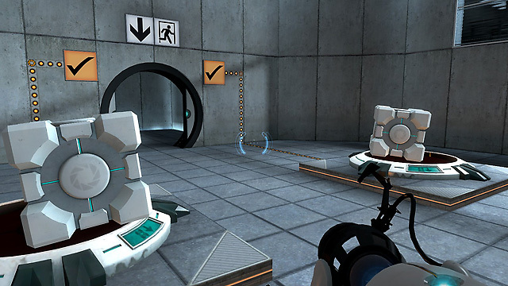

Figure 1

### Quantum Conundrum

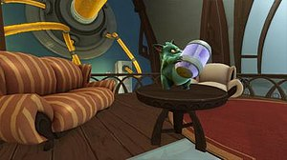Quantum Conundrum is a puzzle-plat that has been viewed from a first-person perspective. As an opposing boy, the athlete can run and jump, participate in various modes, and raise light objects. A player may die by falling into a toxic liquid, endless holes, or falling from a very high altitude, and if he is attacked by harmful lasers; this will restart the player at the beginning of the puzzle. The purpose of each room is to reach its exit door, or it may be necessary to activate some switch or other devices before exiting. (2)

Figure 2

### Portal 2

This game is a puzzle game. The player is to be replaced by Chell in single-player, as one of the two robots which are Atlas and P-Body either in a collaborative campaign or as an icon of humans in the community-developed puzzles. The characters explore nature. The characters suffer moderate damage but will eventually die if they suffer from the injury again. No penalty is faced when falling on a solid surface, but if he falls into endless holes, it will kill the character at that very moment. The motive of the campaign is to explore the Science Laboratory, which is a complex, flexible mechanized mechanics. The majority of the game takes place in modular test rooms with well-defined entrance and exit doors while a certain amount takes place behind the scenes where the purpose is less clear. (3)

Figure 3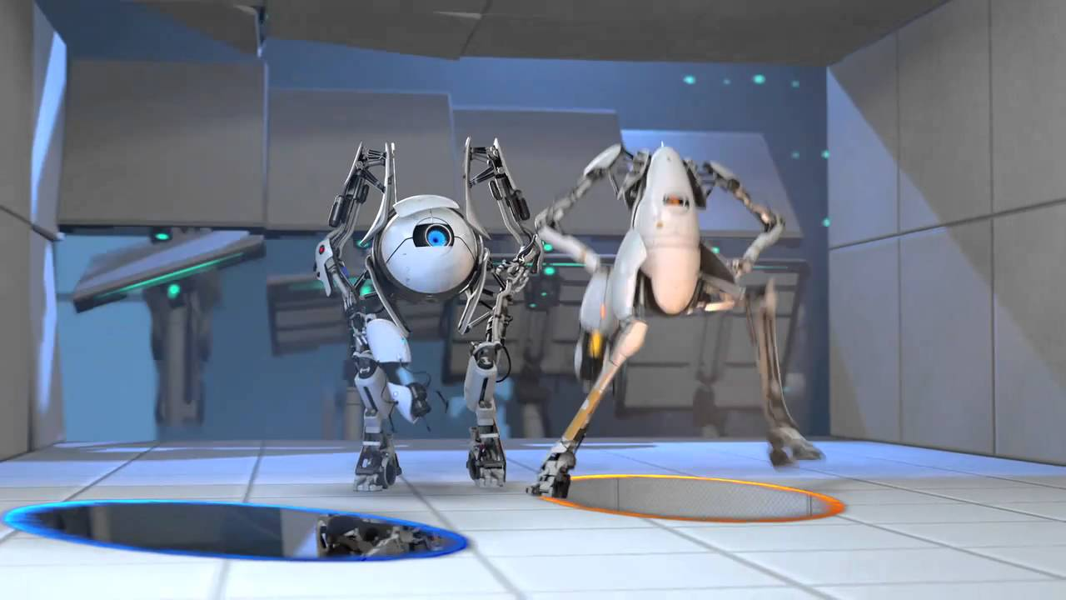

### Half-Life 2

It is a single-player FPS game in which players control Gordon Freeman. It is similar to half-life, especially the health systems, weapons, and periodic physics puzzles. The new source engine and advanced graphics are an exception though. The game is initiated without any particular thing, but slowly and steadily the player builds up his arsenal during the game. Great effort is made to make exploration rewarding and enjoyable even though the game is linear.

Detailed Simulations of physics have been used as part of the new features. A few parts of the game involve driving cars. Environmental puzzles are also introduced with temporary mechanical devices which revolve around the player's ability to pick, move and place objects. The solution to this is to include the physical properties of objects for instance shape, weight, and strength. For example, “Route Kanal”, who is a player is required to place cinder blocks on a temporary ramp so that he could proceed to the wall. The player can also build stairs with blocks, so this proves that puzzles can be solved in different ways.

(4)

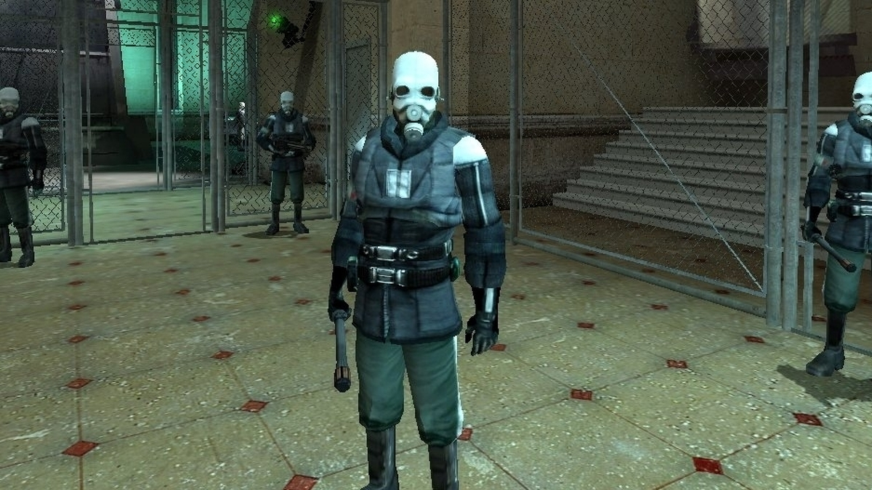

Figure 4

## Stakeholders (Actors)

Following is a list of actors who would be interacting with the game:

1. Players who play the game
2. Parents who buy the game for their kids
3. Game Developers and Designers who create the game
4. Marketers who sell it

## Requirement Elicitation

### Functional Requirements

The functional requirements provide a comprehensive design of the game specifications. These demands will assent to a full knowledge of what this scheme expects. These demands can also offer stakeholders an idea of how the system works and they can decide whether or not the system is per their circumstances

**FR-01: Scripting requirement**

|  |  |  |
| --- | --- | --- |
| Requirement No. |  | Description |
| FR01-01 |  | The game must be implemented in C# |
| FR01-02 |  | The game must be developed in Unity Game Engine |

Table 1

**FR-02: Display, control, and Audio.**

|  |  |  |
| --- | --- | --- |
| Requirement No. |  | Description |
| FR02-01 |  | The game must be controlled with a keyboard and mouse |
| FR02-02 |  | The game must be played on desktop with support for dynamic resolutions |
| FR02-03 |  | The game must feature music and sound effects needed for gameplay |

Table 2

**FR-03: Operating System**

|  |  |  |
| --- | --- | --- |
| Requirement No. |  | Description |
| FR03-01 |  | The game must be playable on Windows |

Table 3

**FR-04: Levels and content**

|  |  |  |
| --- | --- | --- |
| Requirement No. |  | Description |
| FR04-01 |  | The game must provide hints to the user for solving logical puzzles |
| FR04-02 |  | The game must have a new map for each level |

Table 4

**FR-05: 3-Dimensional platformer**

|  |  |  |
| --- | --- | --- |
| Requirement No. |  | Description |
| FR05-01 |  | The game must be viewed from a 1st personal perspective |
| FR05-02 |  | The environment and characters shall be 3-dimensional |
| FR05-03 | | Character’s Health shall be visible within the game |

Table 5

**FR-06: Main Menu**

|  |  |  |
| --- | --- | --- |
| Requirement No. |  | Description |
| FR06-01 | | The game must provide options to view controls |
| FR06-02 | | The game must provide options to select the game level |

Table 6

**FR-07: Single-player**

|  |  |  |
| --- | --- | --- |
| Requirement No. |  | Description |
| FR07-01 |  | The game shall be single player |
| FR07-02 |  | The game shall be FPS |

Table 7

**FR-08: Logical Puzzle**

|  |  |
| --- | --- |
| Requirement No. | Description |
| FR08-01 | Solving logical puzzles must be sub-objective of game |
| FR08-02 | The game shall provide a few hints to solve the puzzle |
| FR08-03 | Puzzle difficulty shall increase with each level |
| FR08-04 | Logical points must be added w.r.t time taken to solve the puzzle |
| FR08-06 | Solving optional logical puzzles must be optional |
| FR08-05 | Logical points for optional puzzles must be added if completed on time |

Table 8

**FR-09: Hunt Animals**

|  |  |
| --- | --- |
| Requirement No. | Description |
| FR09-01 | The player must gain health after hunting energy providing alien animals |
| FR09-02 | The player must lose health after hunting energy reducing alien animals |

Table 9

**FR-10: Fight Robots**

|  |  |
| --- | --- |
| Requirement No. | Description |
| FR09-01 | The player shall be able to shoot robotic enemies. |
| R09-02 | The killing score must be increased if the player kills a robotic enemy. |
| FR09-03 | Killing robotic enemies must be sub-objective of the game. |

Table 10

**FR-11: Game Objectives**

|  |  |
| --- | --- |
| Requirement No. | Description |
| FR10-01 | All sub-objectives must be completed to reach the main objective |
| FR10-02 | Objectives must be do-able and achievable |

Table 11

### Non-Functional Requirements

**NFR01: Performance**

|  |  |
| --- | --- |
| Requirement No. | Description |
| NFR01-01 | Normal game response time should be less than 1 second during gameplay |
| NFR01-02 | The minimum frame rate should be at least 30 frames per second. Smoother gameplay will lead to higher frames per second |

Table 12

**NFR02: Usability**

|  |  |
| --- | --- |
| Requirement No. | Description |
| NFR02-01 | The average user should be able to get familiar with all the controls easily within 3 minutes |
| NFR02-02 | Novice user should be able to get familiar with combat controls easily in less than 5 minutes |

Table 13

**NFR03: Maintainability**

|  |  |
| --- | --- |
| Requirement No. | Description |
| NFR03-01 | The source code of the game must be readable and maintainable |

Table 14

**NFR04: Platform**

|  |  |
| --- | --- |
| Requirement No. | Description |
| NFR04-01 | The game has to run on a window’s-based platform |

Table 15

**NFR05: Resource Required**

|  |  |
| --- | --- |
| Requirement No. | Description |
| NFR05-01 | The user must have a window’s desktop with 4 GB of ram, 128 GB of storage, and a Core i5 processor |

Table 16

**NFR06: Quality Graphics**

|  |  |
| --- | --- |
| Requirement No. | Description |
| NFR06-01 | The game must have good quality 3D graphics |

Table 17

**NFR07: User Interface**

|  |  |
| --- | --- |
| Requirement No. | Description |
| NFR06-01 | User Interface has to be clean and compatible with desktop screens |

Table 18

## Use Case Description

### Launch Game

|  |  |  |  |
| --- | --- | --- | --- |
| **Use case ID: 001 Use case Name: Main Menu** | | | |
| **Priority High** | | | |
| **Actors:**  User | | | |
| **Use Case Summary** | It will enable the user to select different options from the main menu | |
| **Pre-condition:** | The game is launched | |
| **Normal Course of Events** | | **Alternate Path** |
| 1. The use-case begins when the user first launches the game | |  |
| 1. The Main menu shall be exhibited | |  |
| 1. Users can choose many options from the menu. | |  |
| **Post Conditions** | | | |
| Main menu options are available and selectable. | | | |

Table 19

### Design

Figure 5

### Play Match

|  |  |  |  |
| --- | --- | --- | --- |
| **Use case ID: 001 Use case Name: Playable Match** | | | |
| **Priority High** | | | |
| **Actors:**  User | | | |
| **Use Case Summary** | It shall enable the User to control the playable character | |
| **Pre-condition:** | The User has to first select the play-game option | |
| **Normal Course of Events** | | **Alternate Path** |
| 1. The use-case begins when the user chooses the start game | |  |
| 1. Map loads | |  |
| 1. User solves puzzle | | **3(a)** User may enter the wrong answer for the puzzle |
| 1. Kills the boss | |  |
| **Post Conditions** | | | |
| The user solves the puzzle until the level is completed. | | | |

Table 20

### Design

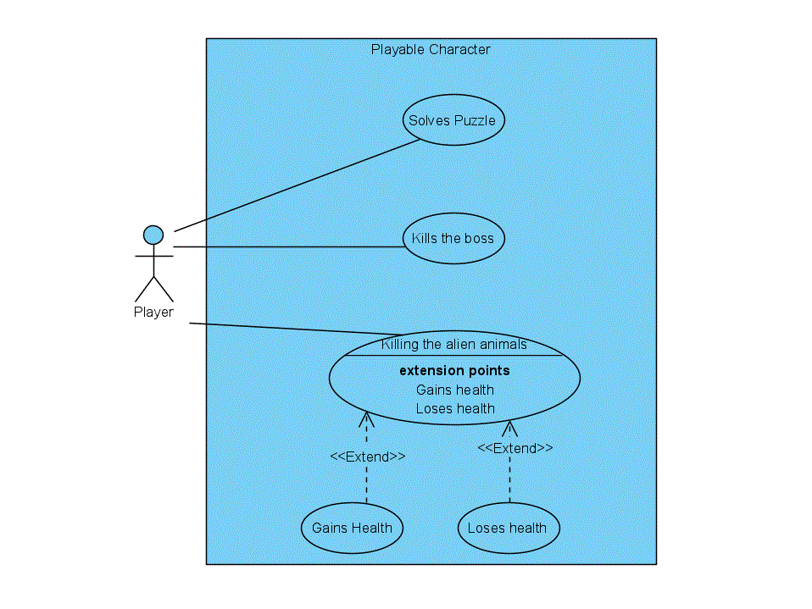

Figure 6

## Game / Software Development Life Cycle (SDLC)

For the development basis of Rogue AI! I have selected the Agile Development model as there are no defined requirements for me to follow other than the baseline of the Game Design. It is natural for developers to experiment with the game and come up with the most workable output. Following are the main principles that have shown to be beneficial and viable for our development.

* Giving Less Importance to documentation and more on developing the actual product by giving high priority to quality
* We have to work on contemporaneous parts of the game to make them fit together.
* This model shall enable to create of prototypes with primitive shapes and test the feasibility of the game system
* In Agile, success isn’t measured through milestones and deadlines, but it is measure through product quality and stakeholder satisfaction.
* As Agile can respond to changes, we were able to adapt to the frequently changing modules due to experimentation of improvisation.

**CHAPTER #3 SYSTEM DESIGN**

# System Design

Chapter 3 shows all the designs that were created for this project:

## 3.1 Work Break down Structure

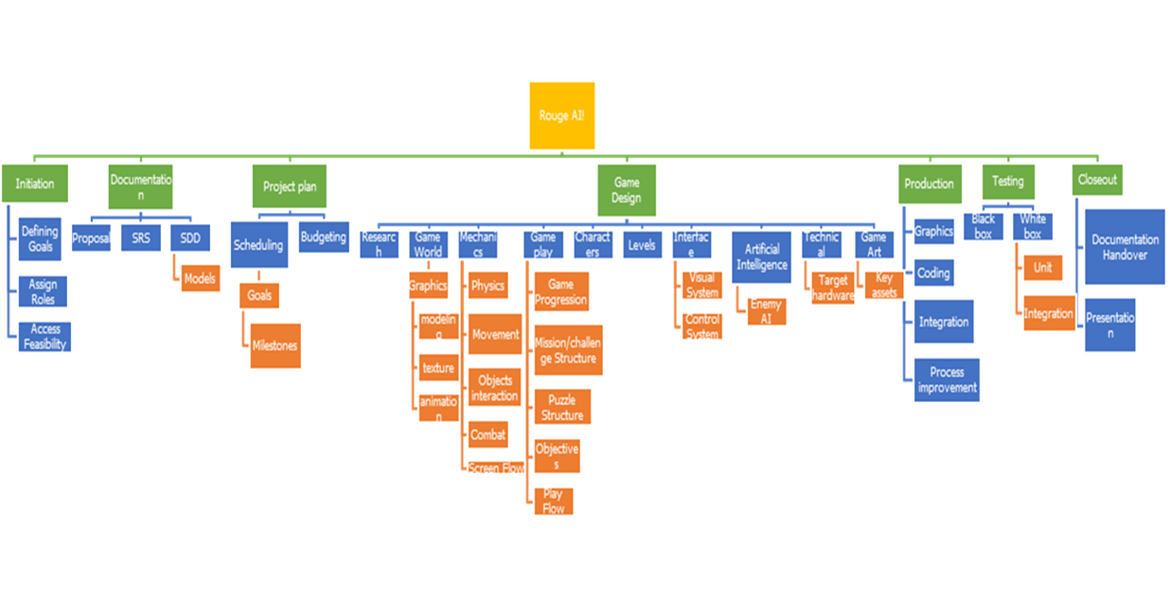The work breakdown structure is as follows:

Figure 7

## Activity Diagram

### Launch Game Activity Diagram

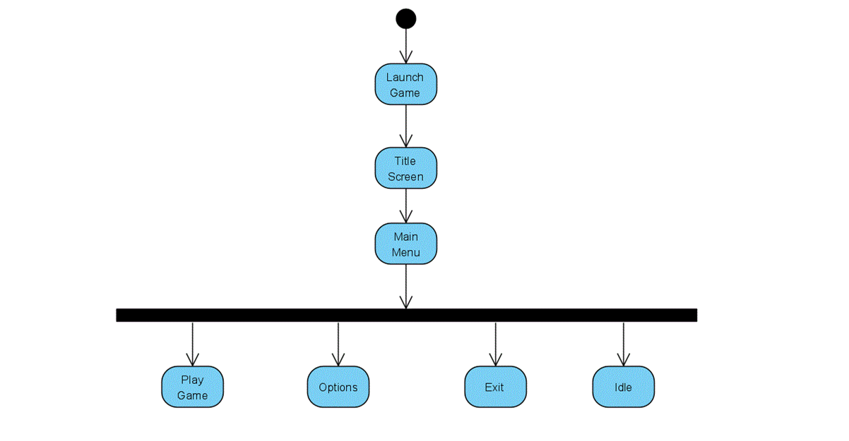

Figure 8

### In Game Activity Diagram

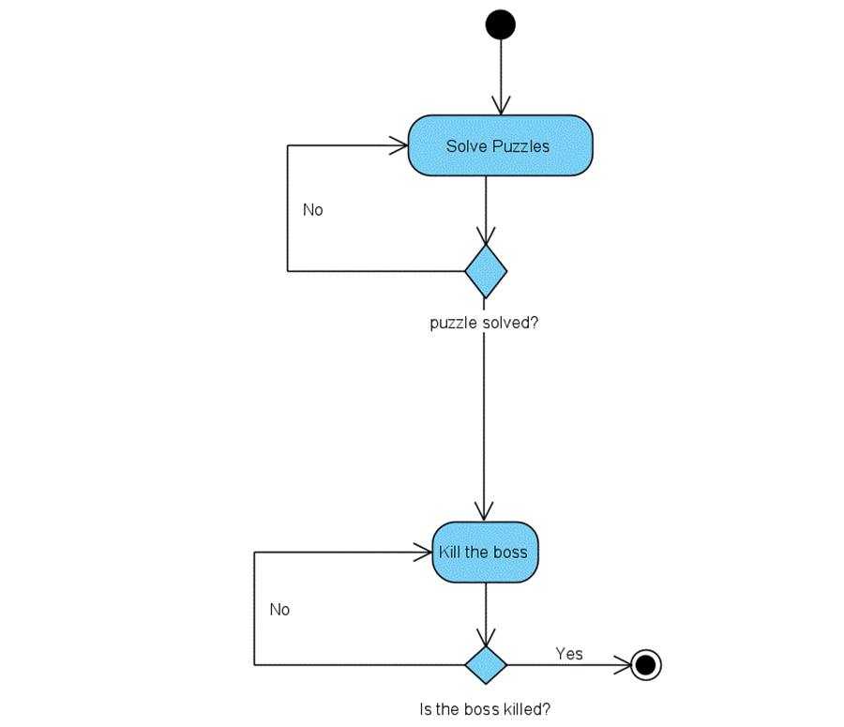

Figure 9

### Game Update Activity Diagram

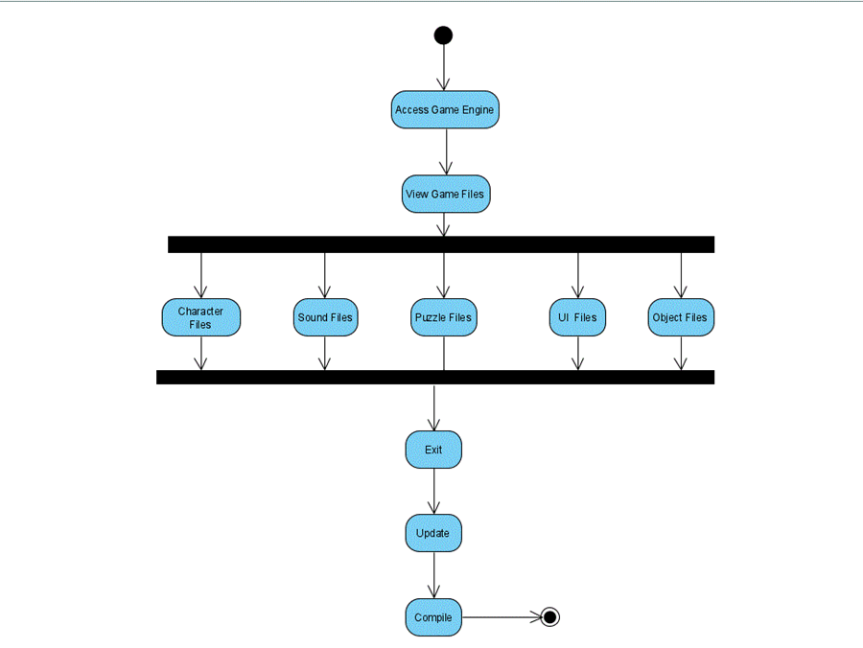

Figure 10

## Class diagram

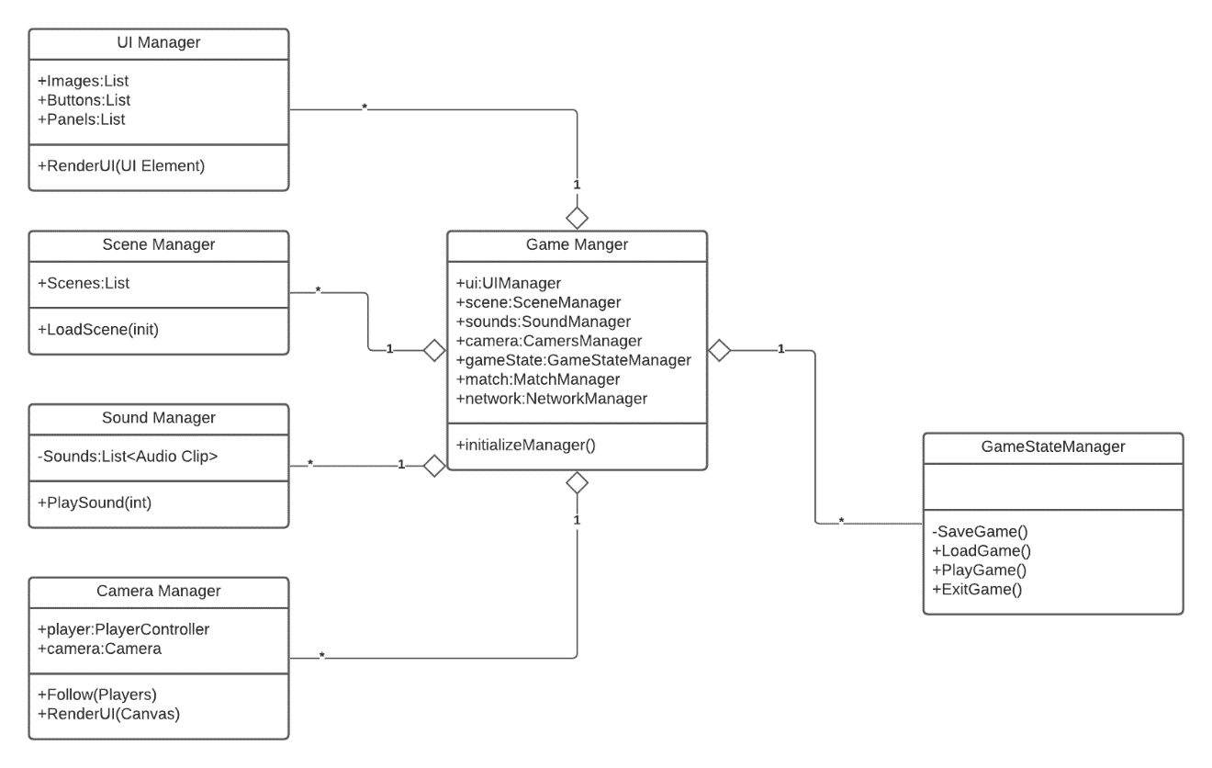

Figure 11

## Sequence Diagram

### Sequence Diagram – Main Menu & In Game Activity

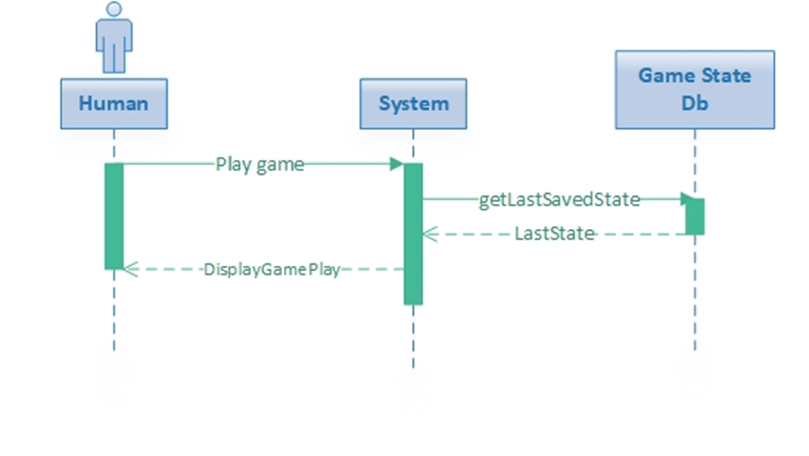

Figure 12

### Sequence Diagram – Update Game

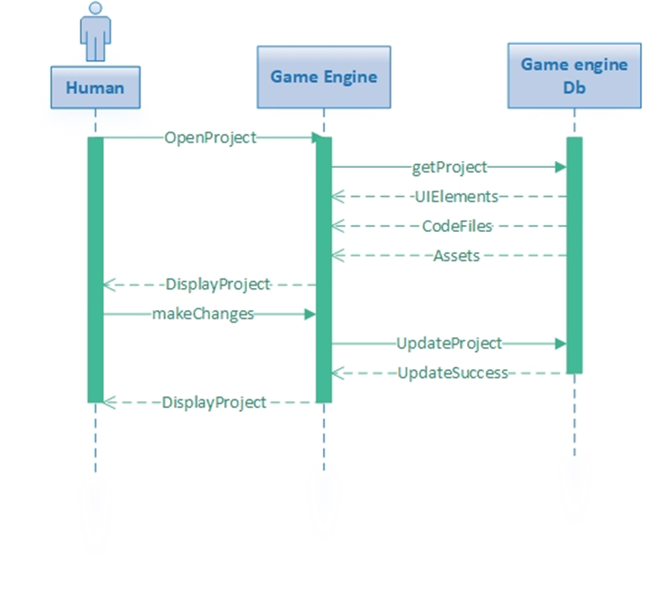

Figure 13

## Game Flow Chart

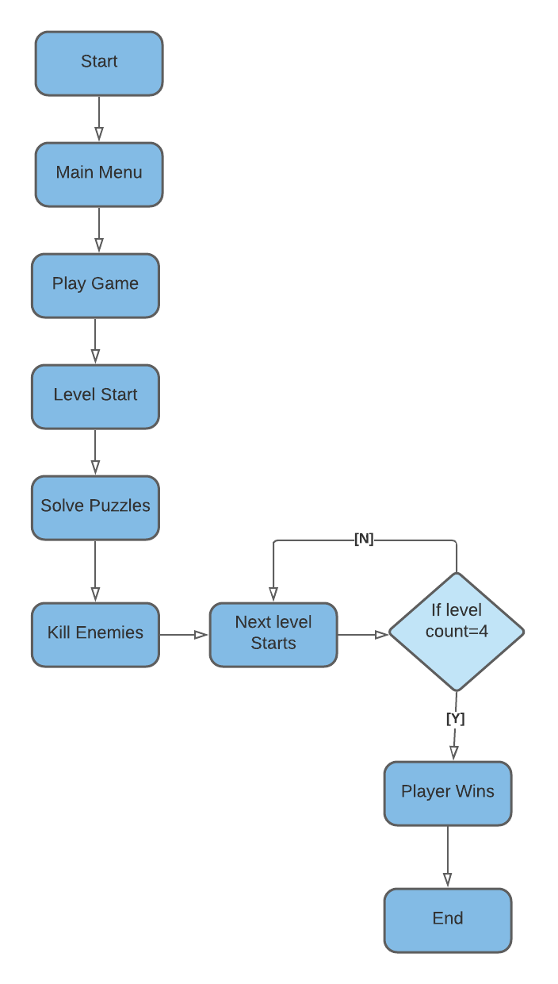

Figure 14

## System Architecture

Figure 15

## Diagram Description automatically generatedCollaboration Diagram

Figure 16

## Game Design and Implementation

### Enemies

The game consists of three types of enemies:

**Guard Bots:** These bots can move and follow the players and can fire. However, they have less health therefore they die easily.

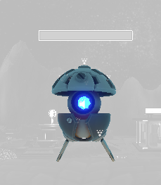

Figure 17

**Defender**: These are immobile; however, they have more health along with more power.

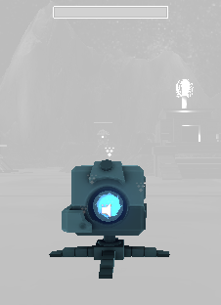

Figure 18

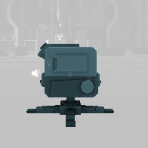

Figure 19

**Boss Enemy:** They have incredible amounts of health and power and can move as well.

### Animals

The game consists of two types of Animals:

**Healthy**: By shooting the healthy animals, the user gets a health upgrade.

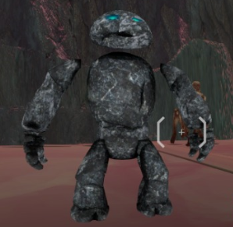

Figure 20

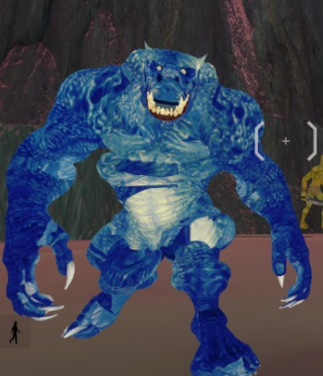

Figure 21

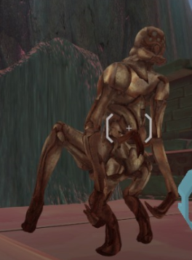**Unhealthy**: By shooting the unhealthy animals, the user’s health decreases.

Figure 22

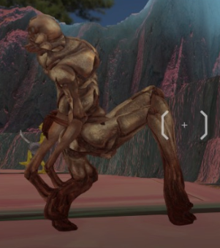

Figure 23

### Player

It is a first-person shooter controller that can solve riddles and can move around

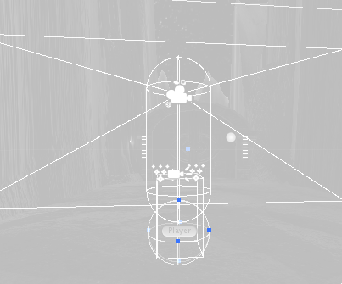

Figure 24

### User Interface

#### Login

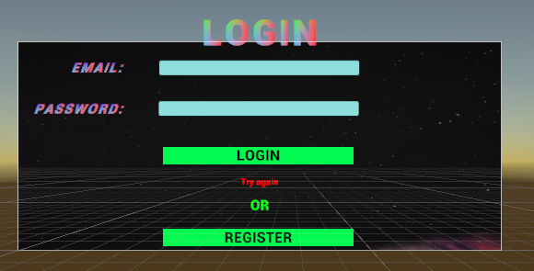

Figure 25

#### Sign up

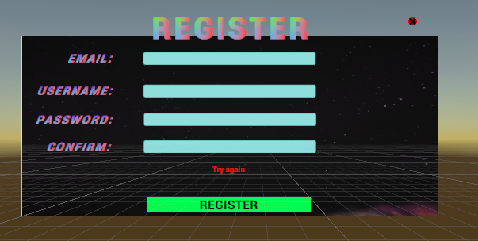

Figure 26

#### Map

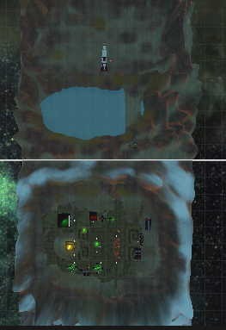

Figure 27

Figure 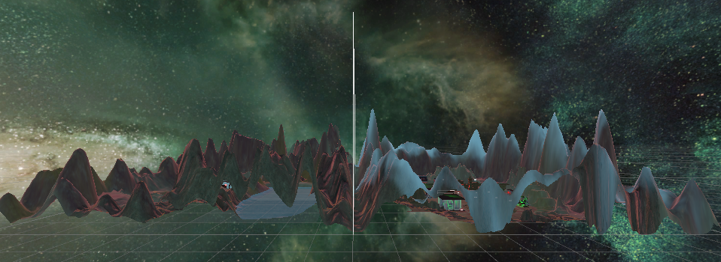28

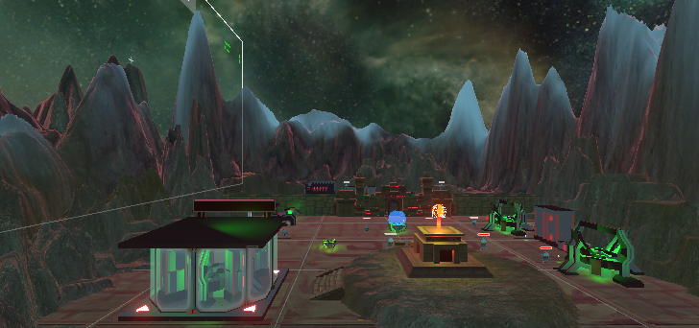

Figure 29

Figure 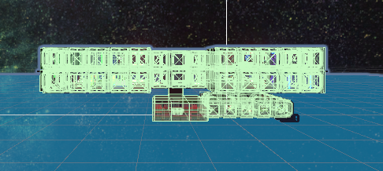30

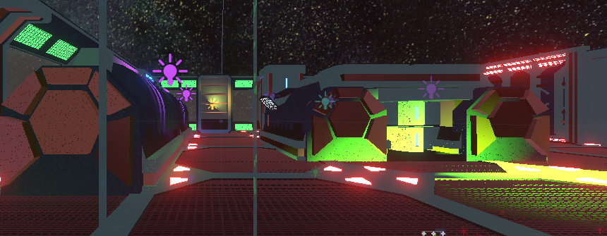

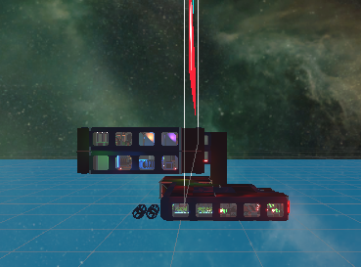Figure 31

Figure 32

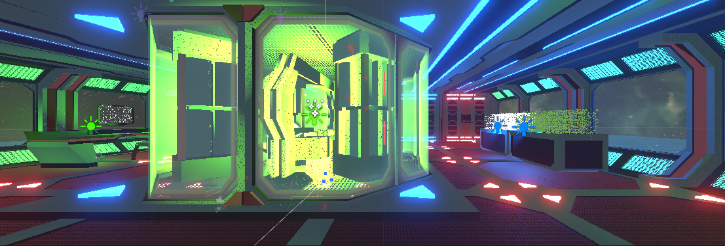

Figure 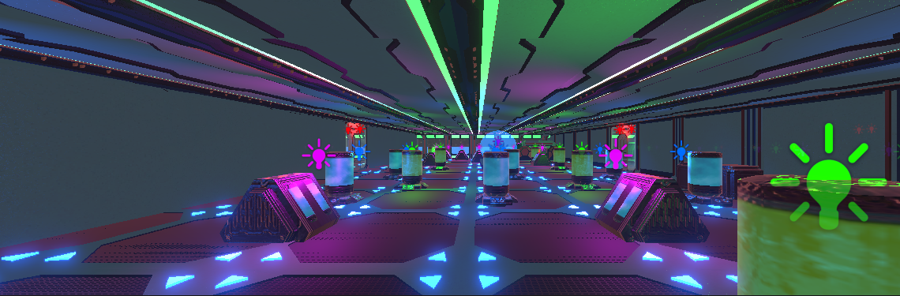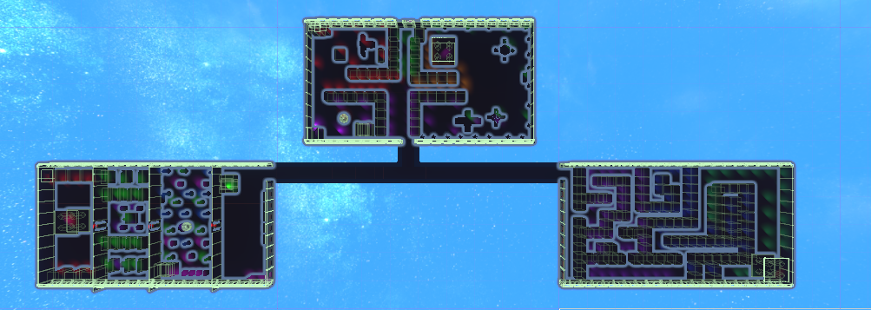33

Figure 34

#### Level screen

Figure 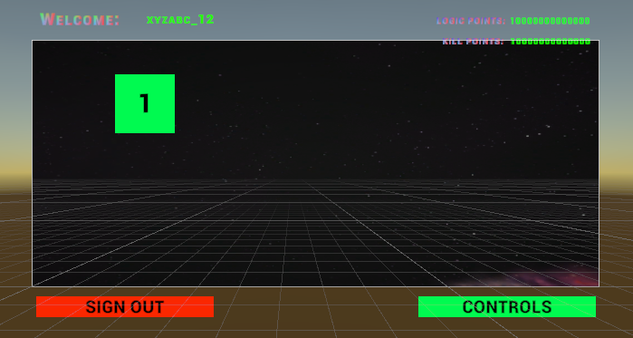35

## Riddles/Logical Puzzles

Riddles are the main focus of our game as they will improve the logical thinking of the users who will play this game.

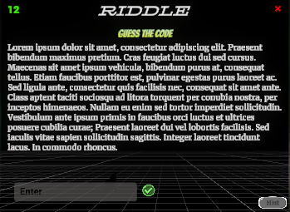

Figure 36

The game consists of **two** types of riddles:

* **Compulsory Riddles**

These are time-based riddles which means that the score will be reduced if the time spent on a riddle is more and without completing this riddle, a player cannot complete a level.

* **Non-Compulsory Riddles**

These are time-bounded which means that if the player solves them in a limited time he will get an extra score, but if he doesn’t he will still be able to play the game.

* + 1. **1+1 =2, 2+3 = 13, 3+3=18**

1-Assess the above-mentioned mathematical statement

2-Find the value of 4+3.

**Hints:**

Square the numbers

**Answer:** 25

* + 1. **DCF=BAD**

1-Evaluate the above statement

* + 1. **Find the value of ECV?**

**Hints:**

1-Evaluating the strings letter by letter

2-Find a sequence within the alphabets

**Answer:** CAT

* + 1. **ETHYL (HERO)FROWN=UNTIL(?)ABEAM**

1-Examine the above statement

2-Find the word that shall replace the question mark?

**Hints:**

1-Compare the two strings letter by letter e.g.: E=U and T=B

2-Replace the letters with the word HERO

**Answer:** TUBE

* + 1. **SHELLS=251442**

1-Examine the above statement

2-What is LESS equal to?

**Hint:**

1-Evaluate the letters of the statement one at a time e.g.: S=2

2-Replace the evaluated letters with the word LESS.

**Answer:** 4122

* + 1. **MEDICAL=5132768**

1-Examine the above statement

2-What is DECIMAL equal to?

**Hint:**

1-Evaluate the letters of the statement one at a time e.g.: M=5

2-Replace the evaluated letters with the word DECIMAL.

**Answer:** 3172568

* + 1. **LOCAL=51325**

1-Examine the above statement

2-What is CALL equal to?

**Hint:**

1-Evaluate the letters of the statement one at a time e.g.: L=5

2-Replace the evaluated letters with the word CALL

**Answer:** 3255

* + 1. **0,2,6,12,20, * ,42**

1-Examine the above sequence

2-What will the digit that shall replace the asterisk (*)?

**Hint:**

Find a sequence between the first few numbers

**Answer:** 30

* + 1. **TRAVEL=451936**

1-Examine the above statement

2-What is LATER equal to?

**Hint:**

1-Evaluate the letters of the statement one at a time e.g.: T=4

2-Replace the evaluated letters with the word LATER.

**Answer:** 61435

* + 1. **12,2,27,11,7**

1-Arrange the following numbers from smallest to largest

2-Identify the middle number

**Answer:** 11

* + 1. **8,13,21,32,47,63,83**

1-Consider the following sequence

2-Identify the wrong term

**Hint:**

1-Find a sequence between the first few numbers

2-Compare it with the rest of the sequence

**Answer:** 47

* + 1. **DEAL=7345**

1-Examine the above statement

2-What is LEAD equal to?

**Hint:**

1-Evaluate the letters of the statement one at a time e.g: D=7

2-Replace the evaluated letters with the word LEAD.

**Answer:** 5347

* + 1. **BOX=CDPQYZ**

1-Examine the above statement

2-What is COAT equal to?

**Hint:**

1-Evaluate the letters of statement one at a time

2-Equate a single letter against two letters of the other side e.g.: B=CD.

**Answer:** DEPQBCUV

* + 1. **1=0, 2=4, 3=12, 4=32**

1-Assess the above-mentioned mathematical statement

2-What is 5=?

**Hint:**

Double the number each time when multiplying

**Answer:** 80

* + 1. **Twelve years ago, John was half of the present age.**

1-Examine the above statement

2-What will be john’s age after 12 years

**Hint:**

1-Find out John’s age today

2-Add 12 years to that number.

**Answer:** 36

* + 1. **Sunday dawned three days before Yesterday.**

1-Examine the above statement

2- What day will dawn two days after tomorrow?

**Hint:**

1-Add three days to Sunday

2-Find out what day it is today after yesterday

3-Find what day it is Tomorrow

4-Add two more days to it

5-Finally, the next day will dawn

**Answer:** Tuesday

* + 1. **CENTRALISATION**

1-Examine the word mentioned above by finding the 3rd, 5th, 6th, 11th and 12th letter of it.

2-Write the middle letter of the word

**Hints:**

1-Make a word using 3rd, 5th, 6th, 11th, and 12th

2-The word will be a five-letter word

3-Find the middle letter of the word found

**Answer:** A

* + 1. **196(25)324**

1- Analyse the above-mentioned statement

2- What number will the * replace in 329(*)137

**Hint:**

Add the numbers before and after the bracket in the statement given above

**Answer:** 25

* + 1. **16(27)43**

1-Analyse the above-mentioned statement

2- What number will the * replace in 29(*)56

**Hint:**

Subtract the numbers after and before the bracket in the statement given above

**Answer:** 27

* + 1. **12(56)16**

1-Analyse the above-mentioned statement

2- What number will the * replace in 17(*) 21

**Hint:**

1-Add the numbers before and after the bracket in the statement given above

2-Multiply the value by 2

**Answer:** 76

* + 1. **10(56)18**

1-Analyse the above-mentioned statement

2- What number will the * replace in 15(*)23

**Hint:**

1-Add the numbers before and after the bracket in the statement given above

2-Multiply the value by 2

**Answer:** 76

* + 1. **143(56)255**

1-Analyse the above-mentioned statement

2- What number will the * replace in 218(*)114

**Hint:**

1-Subtract the number before and after the bracket

2-Divide the value by 2.

**Answer:** 52

* + 1. **188(118)424**

1-Analyse the above-mentioned statement

2- What number will the * replace in 214(*)320

**Hints:**

1-Subtract the number before and after the bracket

2-Divide the value by 2.

**Answer:** 52

* + 1. **The price of a duck is $9**

**A spider costs Rs.36**

**A bee costs Rs.27**

1-Analyse the above statements

2-What will be the cost of the cat

**Hints:**

1-Duck has 2 legs, Spider has 8 legs, and Bee has 6

2-Find out a single value by dividing the price by the no. of legs

**Answer:** 18

* + 1. **A class has a total of 12 kids**

**6 kids are wearing socks**

**4 are wearing shoes**

**3 are wearing both**

1-Examine the above statements

2-How many students are bare feet

**Hints:**

1-Find the number of kids that are only wearing socks

2-Find the number of kids that are wearing only shoes

3-subtract the total no of kids from no. of kids wearing only socks, shoes and both

**Answer:** 5

* + 1. **There are 2 ducks in front of 2 other ducks**

**There are 2 ducks behind 2 other ducks**

**There are 2 ducks beside 2 other ducks**

1- Analyse the above statement

2- How many ducks are there in total?

**Hints:**

1-Imagine the shape to be a square

2-Answer is an even number

**Answer:** 4

* + 1. **BME=DOG**

1-Examine the above statement

2-What is MLC equal to?

**Hints:**

1-Evaluate the letters of the statement one at a time by skipping a letter between them e.g.: B=D (skipping C)

2-Replace the evaluated letters with the word MLC.

**Answer:** ONE

* + 1. **2413,2420,2434,2462,2518**

1-Examine the above sequence

2-Find the last digit after 2518.

**Hints:**

Find a pattern amongst them by subtracting the numbers given above

Double the number for the last digit

**Answer:** 2630

* + 1. **17,35,72,147**

1-Examine the above statement

2-Find the last digit after 147

**Hints:**

1-Find a pattern amongst them by doubling the numbers each time

2-Then add a number each consecutively i.e., 1,2,3,4

**Answer:** 298

* + 1. **4,12,36,108**

1-Examine the above statement

2-Find the last digit after 108

**Hint:**

Find a number such that it will be multiplied by the previous number

**Answer:** 324

* + 1. **10,50,250,1250**

1-Examine the above statement

2-Find the last digit after 1250

**Hint:**

Find a number such that it will be multiplied by the previous number

**Answer:** 6250

* + 1. **62,31,34,17,20**

1-Examine the above statement

2-Find the last digit after 20

**Hints:**

1-The second number is half of the 1st number

2-Then the 3rd number is found by adding 3

3-Follow the sequence

**Answer:** 10

* + 1. **120,108,97,87,78**

1-Examine the above statement

2-Find the last digit after 78

**Hints:**

1-Find the difference between the first two numbers

2-Consecutively reduce the number by 1

**Answer:** 70

* + 1. **17,23,30,58**

1-Examine the above statement

2-Find the last digit after 58

**Hints:**

1-Find the difference between the first two numbers

2-Consecutively increase the number by 1 each time

**Answer:** 47

* + 1. **11,8,16,17,14,28**

1-Examine the above statement

2-Find the last digit after 28

**Hints:**

1-Find the difference between the first and second number

2-Multiply the second number with a value that shall give the third value

3-Add 1 to the third value

4-Follow the sequence

**Answer:** 29

* + 1. **49,48,45,40,33,24**

1-Examine the above statement

2-Find the last digit after 24

**Hints:**

1-Find the difference between the first and second number

2-Find the difference between the second and third number

3-Follow the sequence

**Answer:** 13

* + 1. **5,9,17,33**

1-Examine the above statement

2-Find the last digit after 33

**Hints:**

1-Find a number by subtracting the first and second number

2-Double the value to find the next number

**Answer:** 65

* + 1. **30,25,19,12**

1-Examine the above statement

2-Find the last digit after 12

**Hints:**

1-Find the difference between the first and second number

2-Subtract one number at a time when finding the next number

**Answer:** 4

* + 1. **48,24,12,6**

1-Examine the above statement

2-Find the digit after 6

**Hints:**

Find a value that will give us the next value in the sequence by dividing that value

**Answer:** 3

* + 1. **81,64,49,36,25**

1-Examine the above statement

2-Find the digit after 25

**Hints:**

1-Take the square root of the number

2-Subtract one each time

**Answer:** 25

* + 1. **3,9,4,16,5**

1-Examine the above statement

2-Find the digit after 25

**Hints:**

1-Divide the sequence into two parts

2-One part will consist of the 1st, 3rd, 5th value

3- Second part will consist of 2nd and 4th value

4-Find a pattern within the second part

**Answer:** 25

* + 1. **0,3,8,15**

1-Examine the above statement

2-Find the digit after 15

**Hints:**

1-Find the difference between the first and second number

2-Find the difference between the second and third number

3-Follow the pattern

**Answer:** 24

* + 1. **4,8,11,22,25,50,53**

1-Examine the above statement

2-Find the digit after 53

**Hints:**

1-Divide the sequence in a pair of three

2-Identify the value that is used to multiply the first number to get the second number

3-Identify the value that is used to add the second number to get the third number

4-Follow the sequence

**Answer:** 106

* + 1. **6,10,18,34**

1-Examine the above statement

2-Find the digit after 34

**Hints:**

1-Subtract the second number from the first number

2-Subtract the third number from the second number

3-Identify the pattern

4-Follow the sequence

**Answer:** 66

* + 1. **1,8,27**

1-Examine the above statement

2-Find the digit after 27

**Hint:**

Square the value by adding one each time

**Answer:** 64

* + 1. **6,9,18,21,42,45,90**

1-Examine the above statement

2-Find the digit after 90

**Hints:**

1-Identify the value that is used to add the first number to get the second number

2-Identify the value that is used to multiply the second number to get the third number

3-Follow the sequence

**Answer:** 93

* + 1. **A, H, N, S, W**

1-Examine the above statement

2-Find the alphabet after “W”

**Hints:**

1-Identify the number of alphabets that were skipped between the first and the second alphabet

2-Identify the number of alphabets that were skipped between the second and the third alphabet

3-Identify the sequence

4-Follow the sequence

**Answer:** Z

* + 1. **C, E, H, L**

1-Examine the above statement

2-Find the alphabet after L

**Hints:**

1-Identify the number of alphabets that were skipped between the first and the second alphabet

2-Identify the number of alphabets that were skipped between the second and the third alphabet

3-Identify the sequence

4-Follow the sequence

**Answer:** Q

* + 1. **A, E, I, M, Q**

1-Examine the above statement

2-Find the alphabet after Q

**Hints:**

1-Identify the number of alphabets that were skipped between the first and the second alphabet

2-Identify the sequence

3-Follow the sequence

**Answer:** U

* + 1. **D, G, K, N, R**

1-Examine the above statement

2-Find the alphabet after R

**Hints:**

1-Identify the number of alphabets that were skipped between the first and the second alphabet

2-Identify the number of alphabets that were skipped between the second and the third alphabet

3-Identify the sequence

4-Follow the sequence

**Answer:**

U

* + 1. **A, E, I, O**

1-Examine the above statement

2-Find the alphabet after O

**Hint:**

Vowels

**Answer:** U

* + 1. **A, C, F, J**

1-Examine the above statement

2-Find the alphabet after J

**Hints:**

1-Identify the number of alphabets that were skipped between the first and the second alphabet

2-Identify the number of alphabets that were skipped between the second and the third alphabet

3-Identify the sequence

4-Follow the sequence

**Answer:** O

* + 1. **R, T, P, R, N, P**

1-Examine the above statement

2-Find the alphabet after P

**Hints:**

1-Identify the number of alphabets that were added to the first alphabet to achieve the second alphabet

2-Identify the number of alphabets that were reduced from the second alphabet to achieve the third alphabet

3-Identify the sequence

4-Follow the sequence

**Answer:** L

* + 1. **W, T, P, M, I**

1-Examine the above statement

2-Find the alphabet after I

**Hints:**

1-Identify the number of alphabets that were reduced from the first alphabet to achieve the second alphabet

2-Identify the number of alphabets that were reduced from the second alphabet to achieve the third alphabet

3-Identify the sequence

4-Follow the sequence

**Answer:** F

* + 1. **E, H, L, O, S**

1-Examine the above statement

2-Find the alphabet after S

**Hints:**

1-Identify the number of alphabets that were added to the first alphabet to achieve the second alphabet

2-Identify the number of alphabets that were added to the second alphabet to achieve the third alphabet

3-Identify the sequence

4-Follow the sequence

**Answer:** V

* + 1. **A, D, H, M, S**

1-Examine the above statement

2-Find the alphabet after S

**Hints:**

1-Identify the number of alphabets that were added to the first alphabet to achieve the second alphabet

2-Identify the number of alphabets that were added to the second alphabet to achieve the third alphabet

3-Identify the sequence

4-Follow the sequence

**Answer:** Z

* + 1. **N, Q, L, S, J, U**

1-Examine the above statement

2-Find the alphabet after U

**Hints:**

1-Identify the number of alphabets that were added to the first alphabet to achieve the second alphabet

2-Identify the number of alphabets that were reduced from the second alphabet to achieve the third alphabet

3-Identify the sequence

4-Follow the sequence

**Answer:** H

* + 1. **A, D, G, J**

1-Examine the above statement

2-Find the alphabet after J

**Hints:**

1-Identify the number of alphabets that were skipped to achieve the next alphabet

2-Follow the sequence

**Answer:** M

**CHAPTER # 4**

**TESTING**

# Unity Engine Testing

## Test Case

### Test Case Game Installation

|  |  |
| --- | --- |
| Purpose | Test “Game Installation” |
| Setup | Desktop |
| Step 1 | Unity Setup is to be Downloaded |
| Step 2 | Install Unity |
| Step 3 | Installer file installed successfully |
| Result | **Installed** |

Table 21

### Test Case Game Launching

|  |  |
| --- | --- |
| Purpose | Test “Game Launching” |
| Setup | Desktop |
| Steps | * Does the game launch as it’s supposed to be? * Game displays menu * Play Game * Weapon Select * Settings * Exit |
| Result | **The game launched and menu displayed** |

Table 22

### Test Case Sounds

|  |  |
| --- | --- |
| Purpose | Test “Sounds” |
| Setup | Desktop |
| Verification | * Check ON/OFF Sound and Music * If the sound effects are synchronized with actions in the game. |
| Result | **All sounds and music work as supposed to be.** |

Table 23

### Test Case User Interface

|  |  |
| --- | --- |
| Purpose | Test “User Interface” |
| Setup | Desktop |
| Verification | * Check-in Landscape orientation * Check for screen title * Font displayed properly (color, size, etc.) * Check if buttons are displayed properly * Check If the camera follows the player as it should be. |
| Result | **The user interface works as it should be** |

Table 24

### Test case Performance

|  |  |
| --- | --- |
| Purpose | Test “Performance” |
| Setup | Desktop |
| Verification | * Make sure that any action is not taking a considerable amount of time. * Check if the gameplay is smooth * Check if the loading time is satisfactory. * Check if all assets are loading properly. |
| Result | **Game performance is optimized** |

Table 25

### Test Case Puzzle Solving

|  |  |
| --- | --- |
| Purpose | Test “Puzzle Solving” |
| Setup | Desktop |
| Verification | * Check if the player solves all the puzzle or not * Check if the player is rewarded accordingly. |
| Result | **Puzzle count registered properly** |

Table 26

### Test Case Settings

|  |  |
| --- | --- |
| Purpose | Test “Settings” |
| Setup | Desktop |
| Verification | * Check Settings menu is displayed properly. * Check if the settings menu is working properly. * Check if the settings menu is displaying all the changeable content. |
| Result | **The settings menu is displayed and functions properly** |

Table 27

### Test Case Competition with the boss

|  |  |
| --- | --- |
| Purpose | Test “Play Match” |
| Setup | Desktop |
| Verification | * Check if the player attacks the boss properly or not. * Check if the player is rewarded accordingly. |
| Result | **The Player competes with the boss.** |

Table 28

## Unity Engine Testing:

### Game Installer Files

* Make installable builds with no errors.
* The game does not misbehave according to the design.
* Resource files of the game are installed.

### Models and their Animation

* Character Models are displayed as made.
* Character Animations plays animated.
* Textures render as made.
* HUD showed as designed.

### Player Game Object

* Can solve puzzles.
* Can kill the enemy.
* Can kill the right Alien Animal and improve its health.

### Game Menu and Interfaces

1. Level selection is ensured
2. Look Sensitivity can be changed in Game Menu
3. An overview of control is possible in Game Menu
4. The screenshot has been enabled in Game Menu as well

**CHAPTER # 5**

**CONCLUSION**

# Conclusion

## Problem Faced and Lessons Learned

Game development is teamwork. Every person has their role when it comes to the development process but as per the current situation, we weren’t able to clear out our details for a long time. Though we had several meetings, it takes time for an individual to understand the entire concept through online sessions. Face-to-face interaction easily solves a lot of ambiguities that rose for us this Semester. Documentation, Research, Planning, Implementation, and Testing together make a game. So, it indeed was difficult for us somehow.

Lessons learned is that we need to invest ourselves in Game development as it helps to learn concurrency as well as it helps to learn about performance and user experience.

## Project Summary

Rogue AI! is a game that is developed on Unity Engine for Desktop. It is being developed by keeping the constraints and limitations of the devices in view. It is developed to improve the logical thinking of the player as the player is to solve logical puzzles. The first four levels are crossed by solving the logic puzzle. The last level is to be solved by killing the boss's enemy. In between the game, the player has the option of regaining his health by killing the right Alien Animal, this shall boost his health.

## Future Work

We have some plans of taking this game to new levels by adding some secret assets after achieving the currently planned milestone. We are looking forward to adding wonders to it.

Future extension of this work may include:

* New designs
* Puzzle scenarios
* More players and enemies
* More Levels
* Interplanetary
* Reward schemes
* Daily Login Bonuses
* Different techniques of gaining health

## GitHub Repository Links

<https://github.com/humza-13/Rogue-AI>

**CHAPTER # 6**

**REFERENCES**

# References

## Portal Game Play

<https://www.youtube.com/watch?v=XUp9arduWTg>

## Portal Wikipedia

<https://en.wikipedia.org/wiki/Portal_(video_game)>

## Portal 2 Wikipedia

<https://en.wikipedia.org/wiki/Portal_2>

## Half-life 2 Wikipedia

<https://en.wikipedia.org/wiki/Half-Life_2>

## Quantum Conundrum Wikipedia

<https://en.wikipedia.org/wiki/Quantum_Conundrum>

## PUBG Mobile Wikipedia

<https://en.wikipedia.org/wiki/PlayerUnknown%27s_Battlegrounds>

## COD Mobile Wikipedia

<https://en.wikipedia.org/wiki/Call_of_Duty:_Mobile>

